Survive in space where aliens want nothing but to see your destruction.

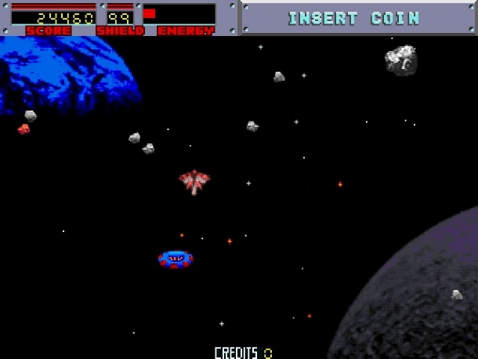 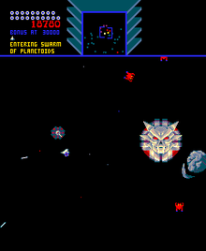

Genre: Omnidirectional Shooter

Controls: KB/Touch/Controller

Thematic Setting: Space

Tech Stack: raylib 5, MagicaVoxel, Labchirp, Audacity

Style: 3D assets with 2D gameplay and UI

Platform(s): Windows/Linux/Web/Android (Web is a must for game jam)

Game Moment: You must stop the aliens in their tracks as they attempt to do away with you.

Game Summary: While out scouting unexplored space, you happen upon unfriendly aliens that want nothing but to destroy the humans. You were lucky to find out about them before they were able to launch their evil plans of wiping out all the human colonies and destroying Earth, as they see humans as a virus that must be eradicated. It is up to you to make a stand, and keep them out of known space! The best part is the fighting happens in asteroid fields! The aliens are gathering resources from the asteroids to build their most powerful enemy, the dreadnought, so you also have to stop them in their tracks or it will be Game Over man, Game Over.

Art style is 3D voxel assets to give it a modern but 80s arcade look. Audio will sound like 16-bit sound effects. Music should sound like it was made using an Amiga Mod style.

The player remains in the center of the screen as the game world moves around them. In other words, the camera stays with the player. The size of the world should be about a three-by-three screen size grid. Screen size will be my standard 960 by 1280 sized window. Play area is wrap around with radar like Sinistar.

Game inspiration is Blasteroids and Sinistar.

Feature Development Priorities:

* Arcade omnidirectional shooter. Defend yourself, pick up power ups, and keep the invaders from gathering resources to build their Dreadnought!
* If player gets shot, or hits an asteroid/enemy shield damage is taken, if shield is out of energy, hull damage is taken. Hull damage cannot be repaired.
* Shield is powered by crystals that enemies and asteroids drop. The Ultra Lazer is powered by crystals as well. Red for UL and Blue for shield.
* Enemy collects all crystals to build their Dreadnought.
* If enemy shot, drops any crystal that was collected.
* Radar for player to see enemy and asteroids.
* Only the Ultra Lazer can damage the Dreadnought.
* There are multiple types of enemies. Worker, Seaker, Hunter Killer, and Hazard.
* Player ship power ups for weapons, shield, armor/hull.